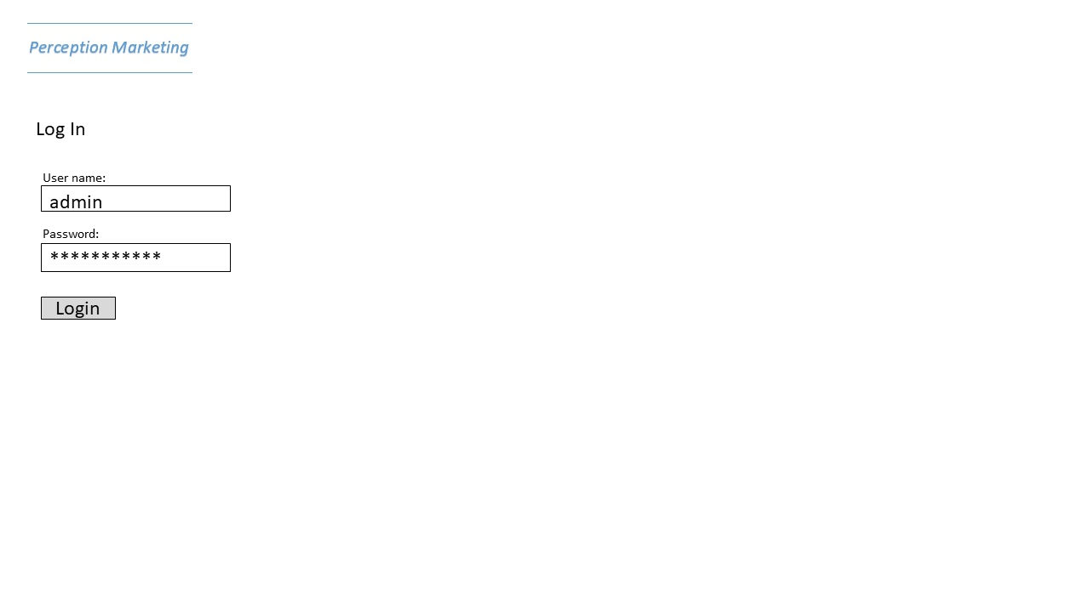

Login page: We can’t have just anyone signing in without authorization to ‘Perception Marketing’ employee records. This verification step protects the employee’s data integrity. Our current default sign-in is username: “admin”, password: “monkey”.

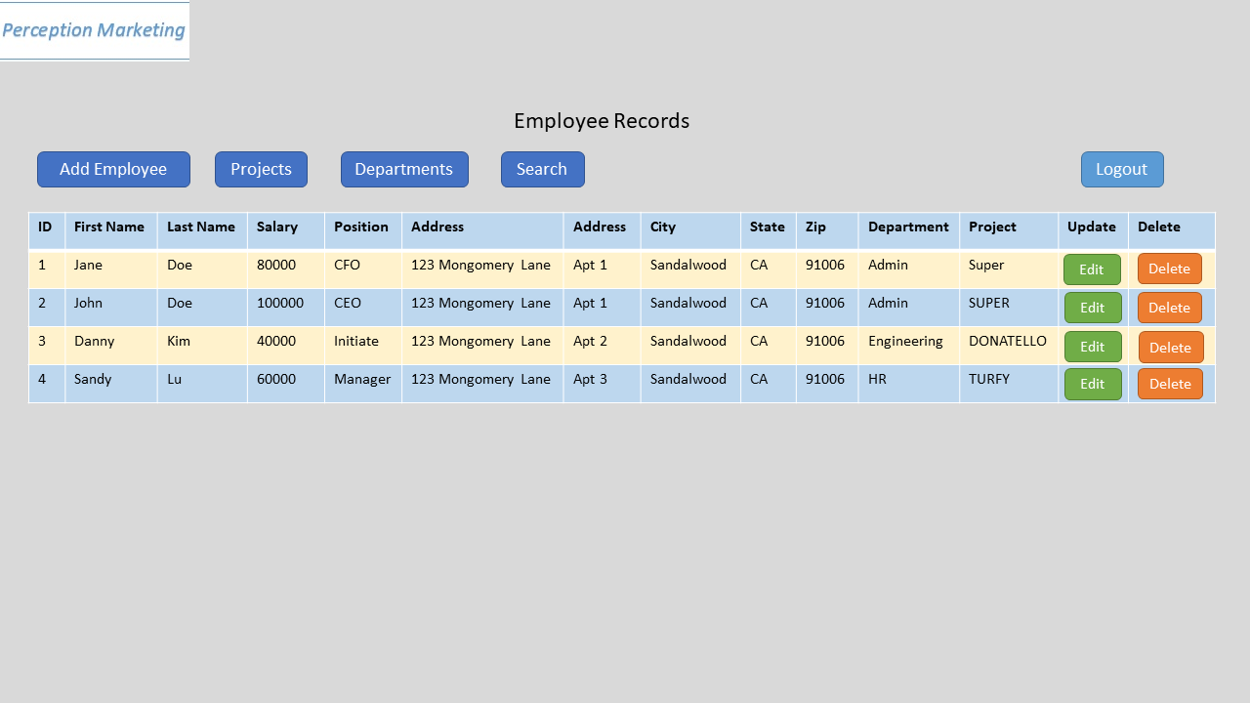

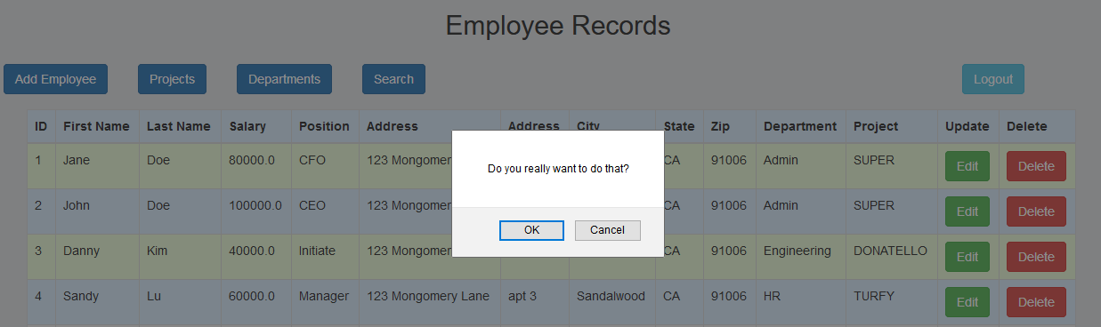

A sample listing of our Employee Records: This listing consists of all the employees currently employed at ‘Perception Marketing’. The list contains employee names, salary, position, address, department, etc. Also included is the edit and delete buttons for quick edit/delete of employee records. A pop-up confirmation window when you click ‘delete’ an employee. The names of employees are listed in alphabetical order by last name, first name for easy finding. Navigation buttons are also added to help with navigation to the project, department and searches page. When there is no longer a need to view, edit, delete or add an employee, just simply click ‘logout’ and it’ll send you back to the login page where authorization is needed again.

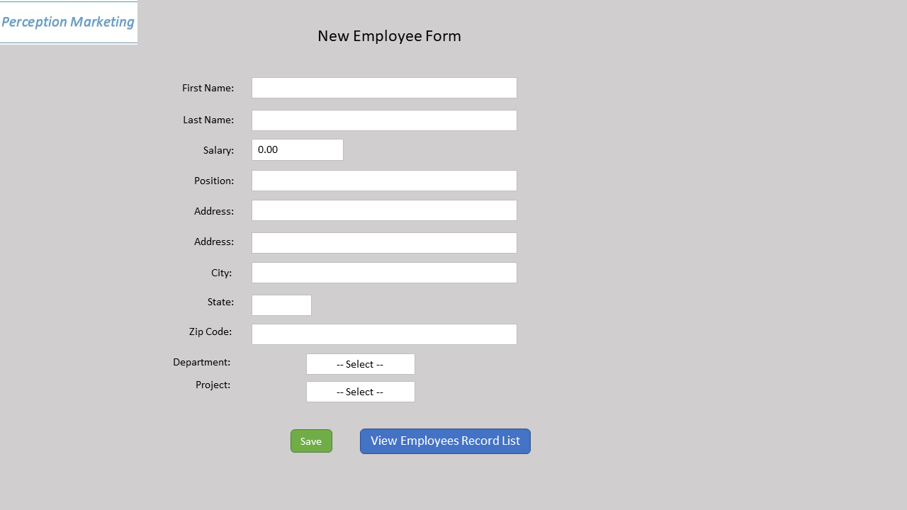

New Employee page: When a new hire joins the company, the hiring manager need only to fill out this simple form. Complete with list boxes for Department and Project names. A default project or department can be created and assigned if you need more time to decide what department or project the individual should be assigned. Click on the ‘save’ button if you want the save the new employee or simply click ‘view employees record list’ to exit back to the employee listing page.

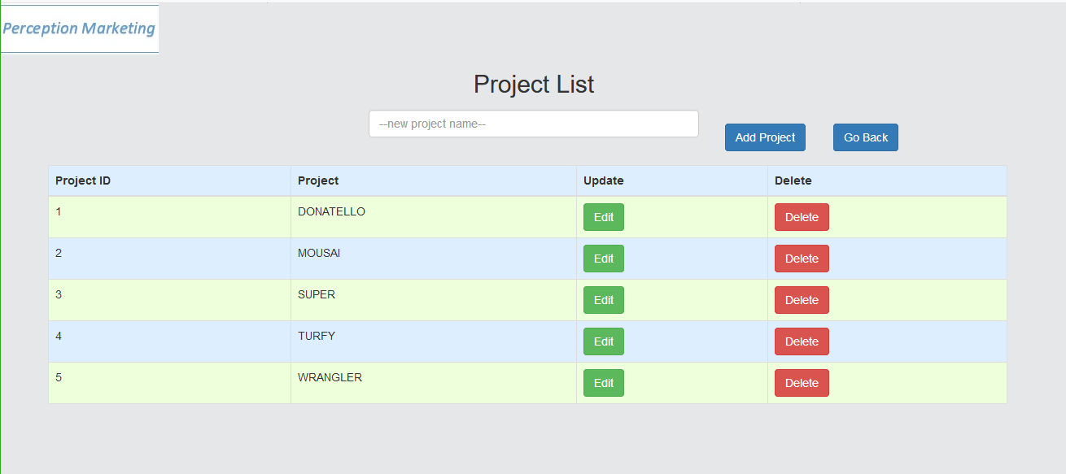

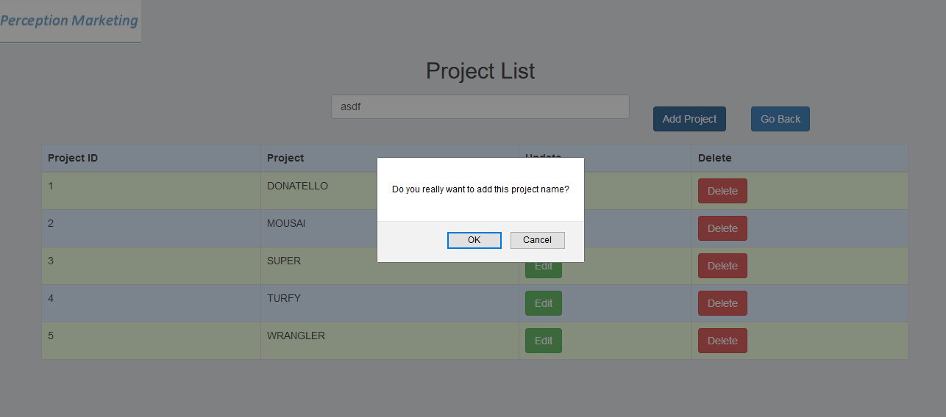

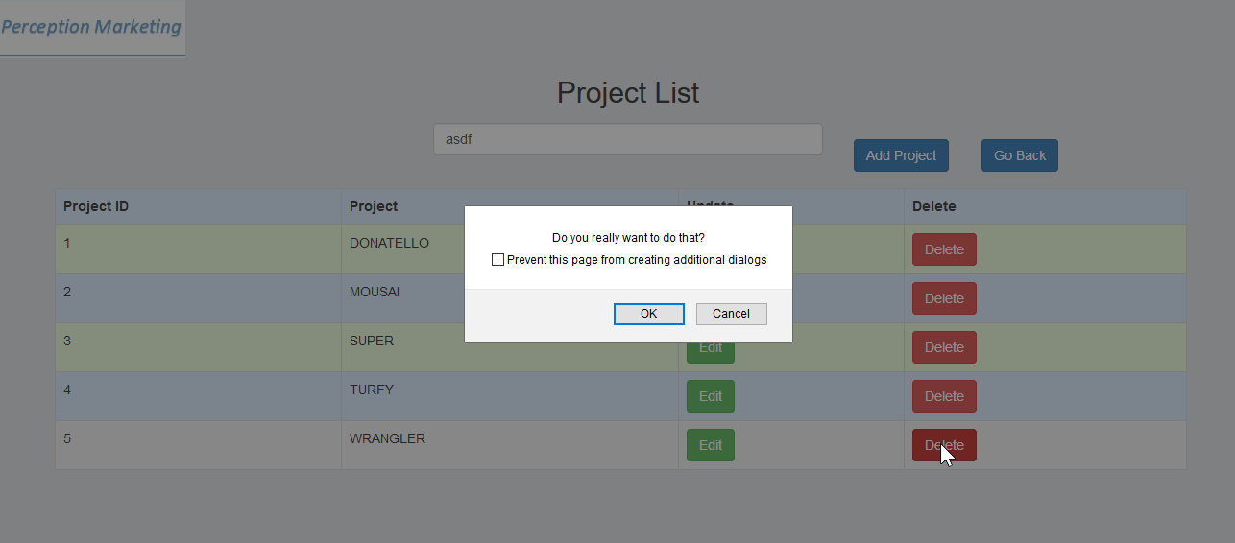

Project List page: This page allows for quick adding, editing and deleting project. The names of projects are in alphabetical order. Also a confirmation page is added for delete and adding new project name. A ‘Go Back’ button is added for easy navigation.

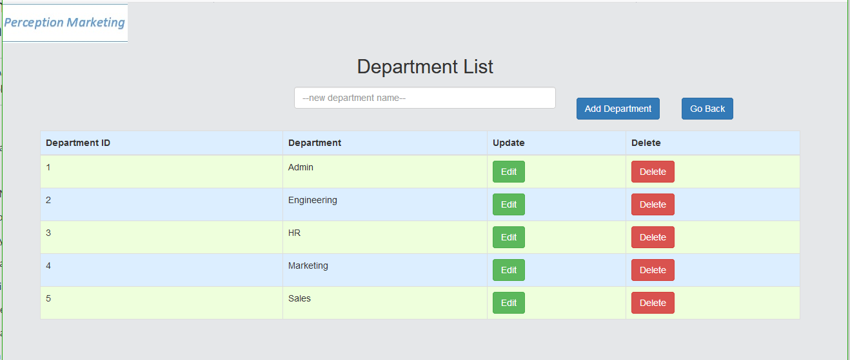

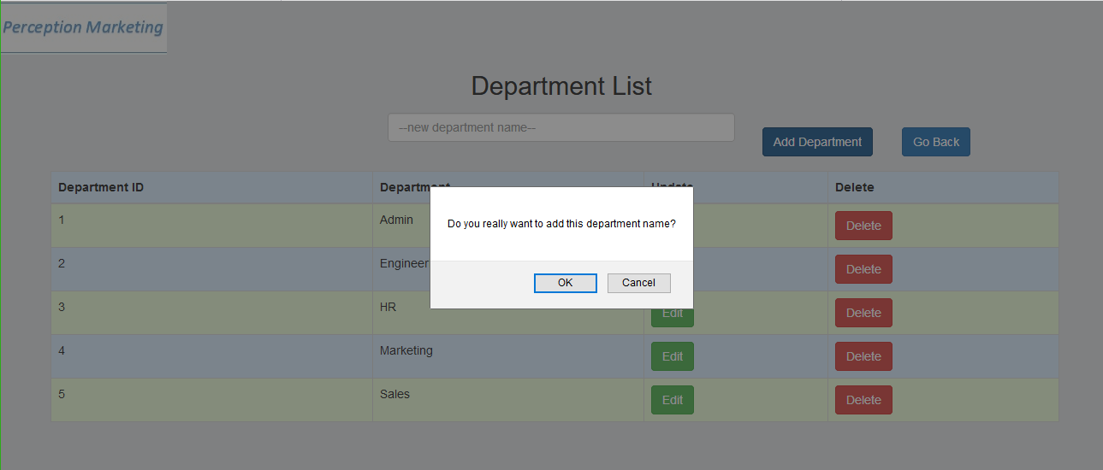

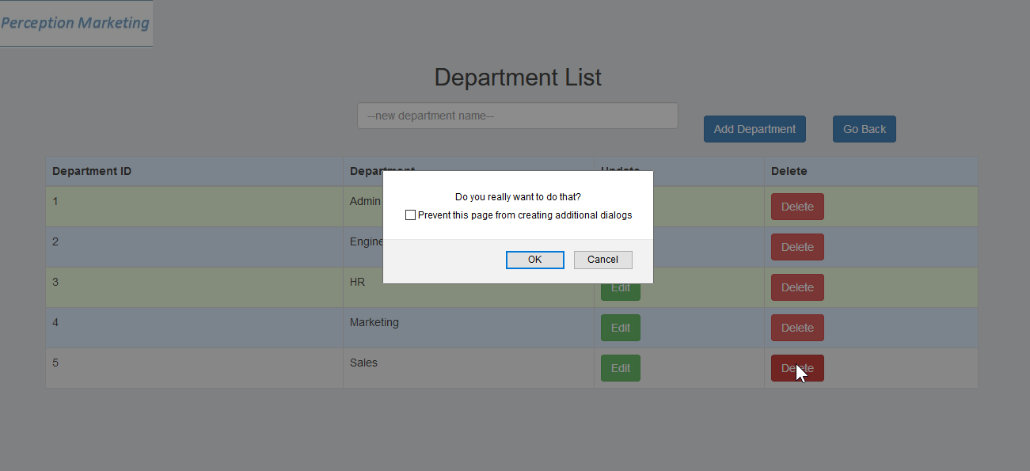

Much similar to the Project Listing page, the buttons work the same except this is for Department creation, edits and deletion.

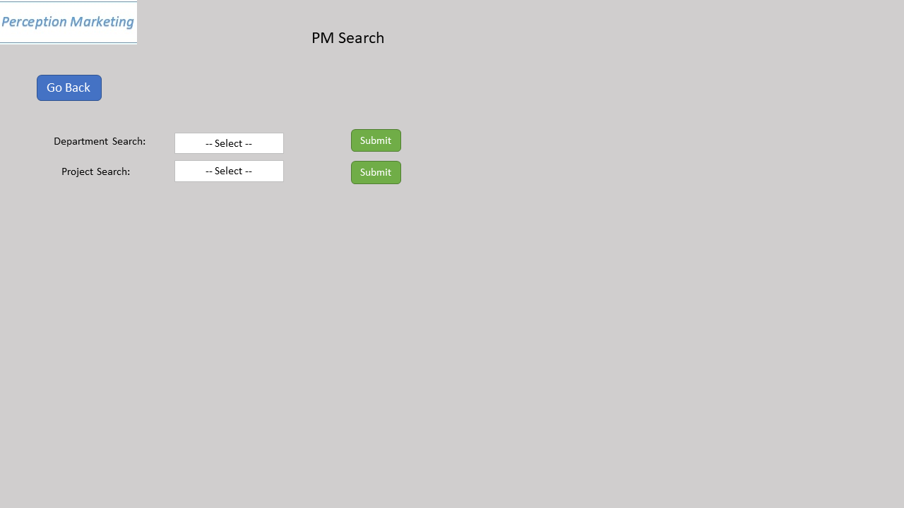

Lastly, the search page is design to help search for employees in specific departments or projects.

